AgileMind: User Manual

**Team Members :**

**Kendall Bingham**

**Vidya Sridhar**

**Table of Contents**

# Topic Page No.

# Introduction 3

**System Use 4**

**Error Handling 6**

**Sample Interaction 7**

**Bugs to be Resolved 18**

# Introduction

Problem Statement : Develop retentive games for children and adults combating mental ailments like Alzeihmers.

Motivation & Objective :

Our overall goal is to design a web based mobile interface, that provides a simple, easy to play game for both children and adults, for educational purposes. Retention can be achieved and will not only be stimulating but also therapeutic.

Proposed Approach:

The approach is to build a website that provides a clean GUI having several games, each aimed at a particular facet of memory awareness : long term memory, short term memory, color recognition, etc.

Significance:

Brain diseases like Alzheimer’s have unfortunately increasingly become common among adults beginning at an age as low as 40. These games would help stimulate brain retentiveness. Simple pre answered questionnaires could serve as input, to be tested against several times (depending on the stage of memory degradation of the patient) and be incorporated via a simple game with a neat GUI.

In addition, children can also use this application to identify shapes/symbols/colors, etc. that woulbe useful in learning. Winning the game would prove incentive in learning their essential requirements like their home address, phone no., etc. asked as a part of the application.

In short, this application can be used as a powerful tool when it comes to stimulating thinking power.

# System Use

Style of User Interaction

The system consist of a website and a mobile website. It consists of four games and a progress report. The following features are implemented :

**Framework Specification :**

Assumptions and Constraints:

While the research is not conclusive about brain exercises and warding off Alzheimer’s, there is a lot of promising evidence that it may help. Users must have a phone or computer with connectivity. While HTML 5 may not be required for all activities JavaScript will have be enabled and running for the web clients both mobile and desktop browser. The android phone development will only require internet connectivity. This will not be a solitary program, but will always require connection to the cloud. Users will also need to be somewhat savvy with cell phones and computers. They will also need to be able to read.

The games themselves will be aimed at :

* Color Recognition : Match Color Game wherein the user will have to choose the right color of the word he sees.
* Short Term Memory : The user is given a series of comprehension passages, following questions he needs to answer.
* Long term Memory : The user is first asked to create a user profile, from which questions will be randomly selected and given.
* Identify Objects : Here images are given to the user, from which the user will select the right image.
* Progress Bar : Summary charts will be shown in the end, indicating the progress, and the time and seconds is shown at the end of every quiz , including a progress bar after each question.

**Technological and Architectural requirements:**

* Knowledge of c# to work on Visual Studio 2010 DotNet 4.0
* SQL server 2008
* Jquery, JavaScript, JQueryMobile, KnockoutJS, HTML 5, android
* Access IBM smart cloud enterprise

Overall System Architecture Diagram :

Deployment Diagram

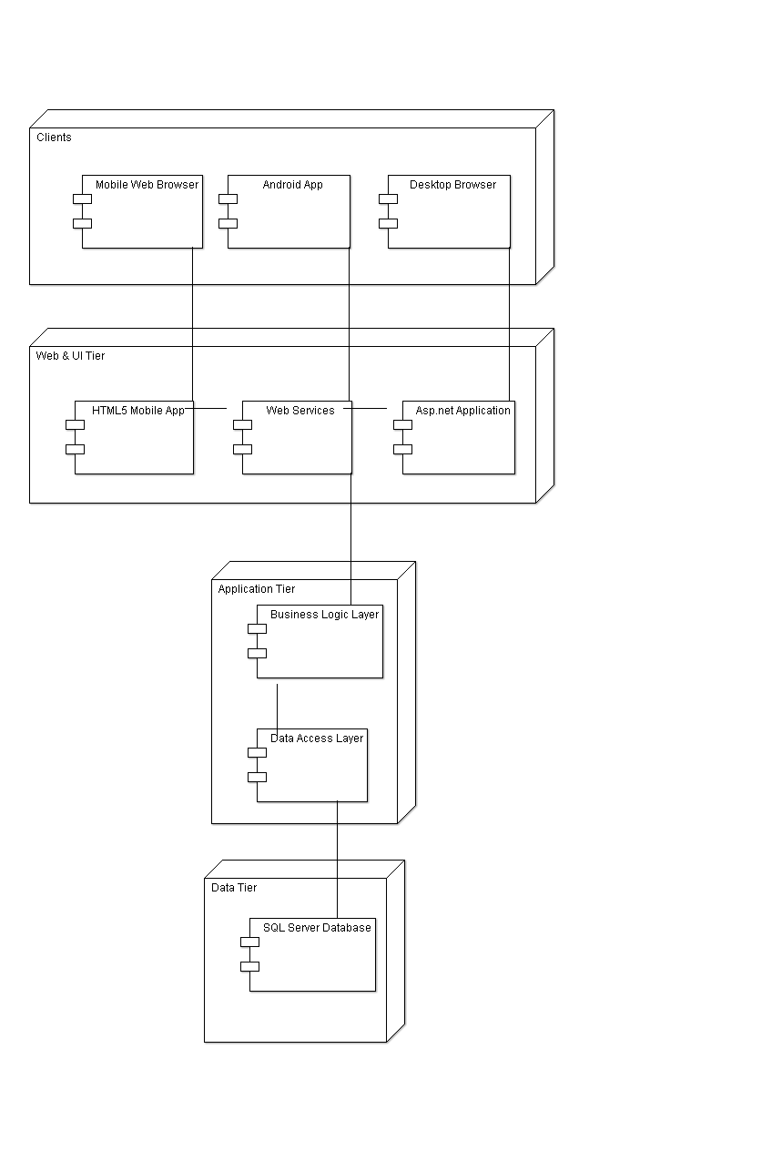

# Error Handling

* Log in Page : The user should first register for the game, and only then is he allowed to log in and use the game. Otherwise, a message is displayed saying he must first register.
* If a password of length less than 6 is detected a message is shown.
* If the wrong password and name is input, an error is shown.

Here the focus is on the security. The answers to the questions can be correct or wrong. The Percentage of correct answers is shown.

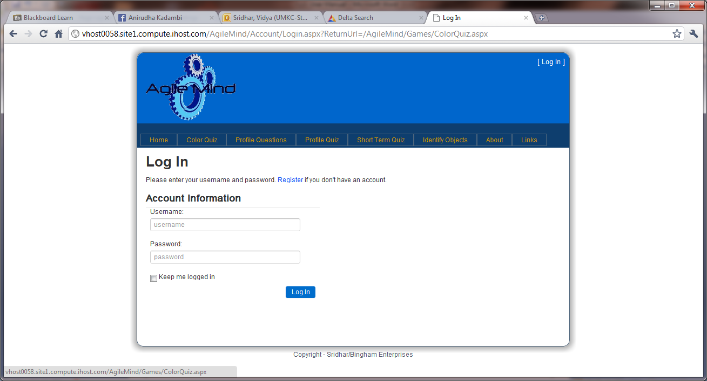

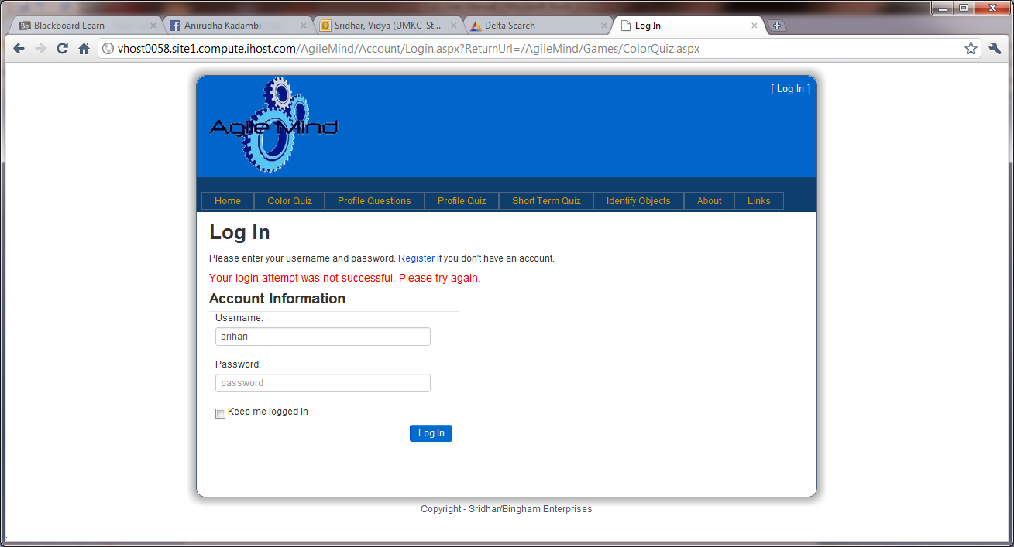

# Sample Interaction

1. The user logs in, after registering with his user name and password.

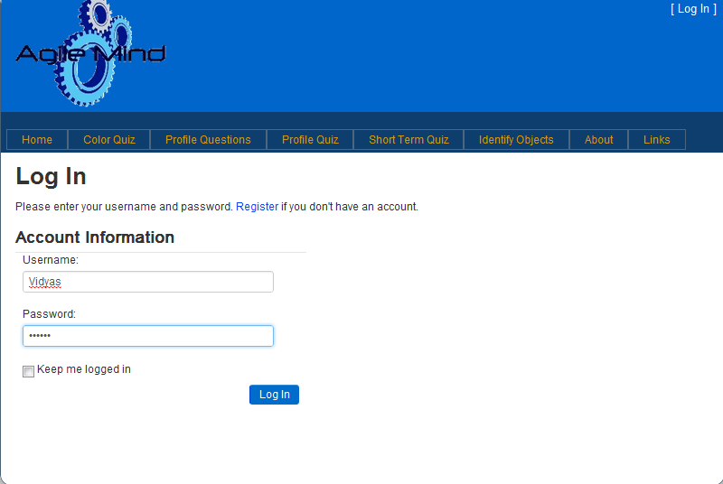

1. He chooses the color game

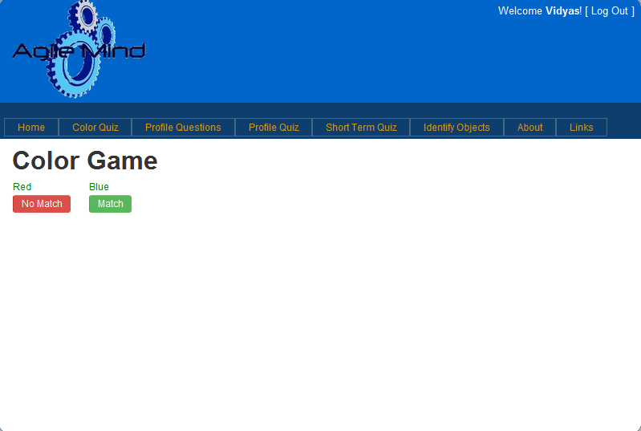

He must choose the word on the right whose color is mentioned on the left word.

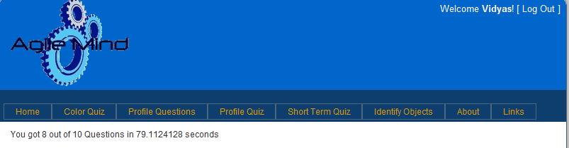

Progress is shown.

1. He chooses the Profile Quiz. He first begins by entering inputs for the Profile Questions.

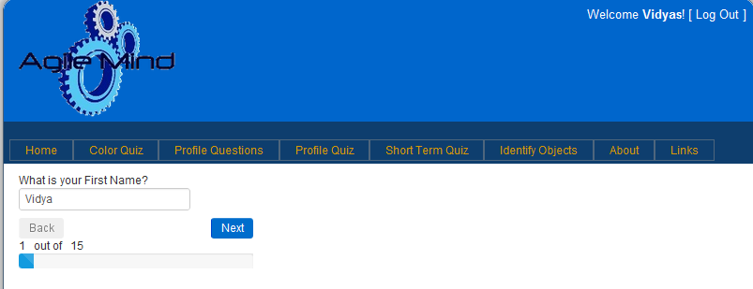

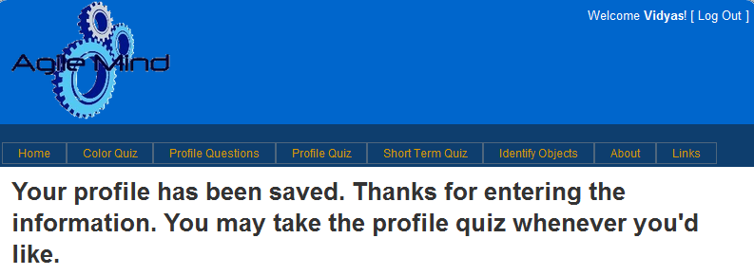

He then takes the profile quiz.

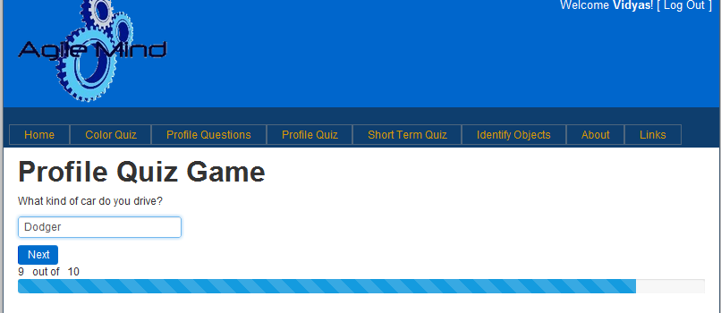

His progress is shown



1. He chooses the Short term quiz.

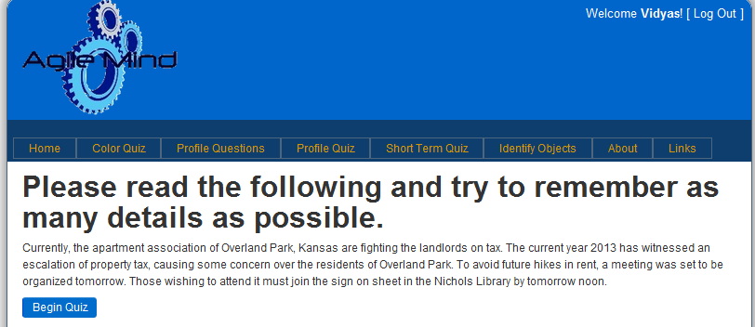

After he clicks on “begin quiz”, he is asked questions based on that after 15 seconds.

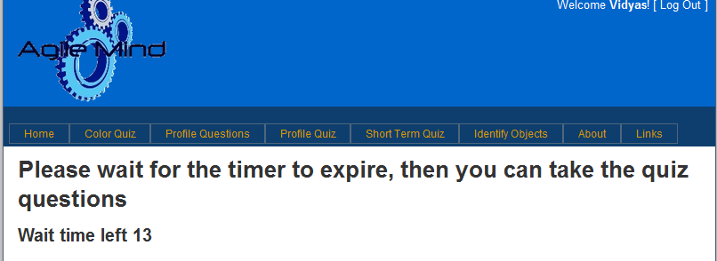

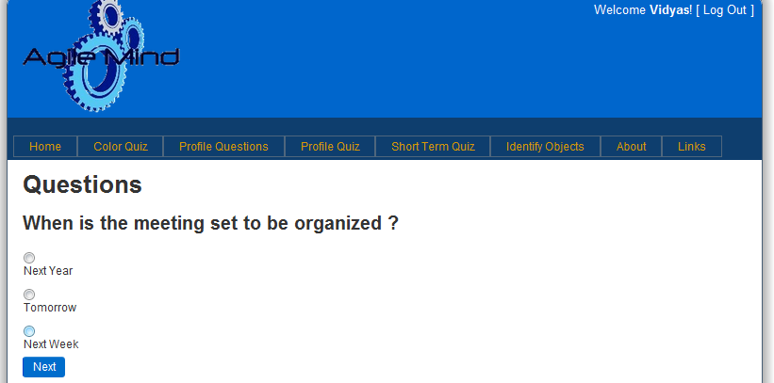

His progress is shown.

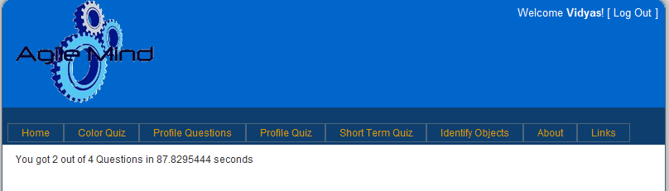

1. He chooses the Identify Objects quiz

Here, images are displayed, of which the right one he must choose.

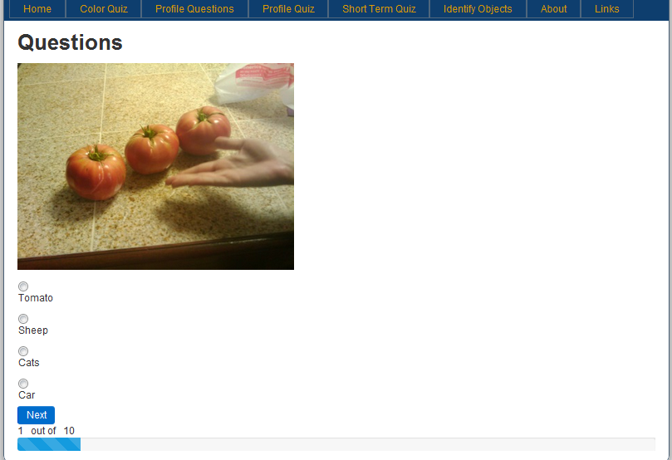

His progress is shown again.

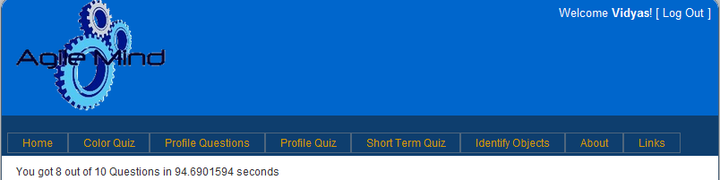

1. He goes to Home and sees his progress

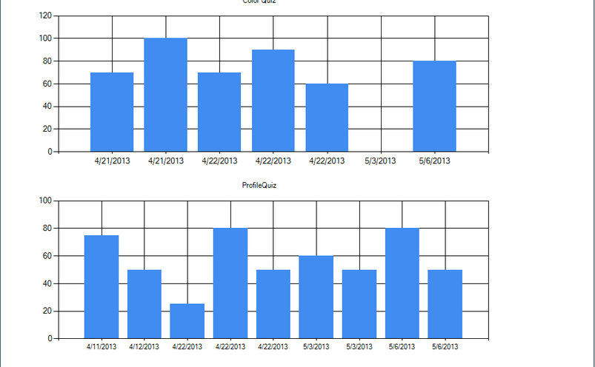

Mobile Website :

1. He logs in



1. He chooses from the menu



1. He plays the color match game



1. He plays the profile game



1. He plays the Short term quiz game

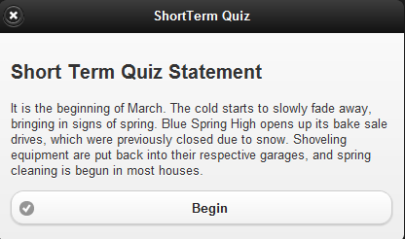

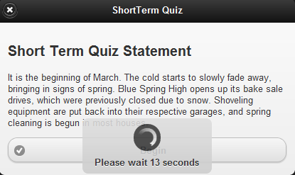

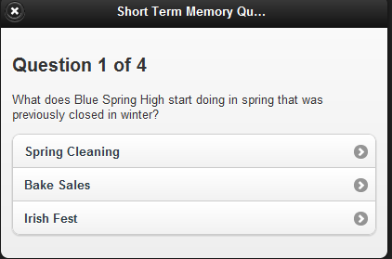

1. He plays the identify objects game

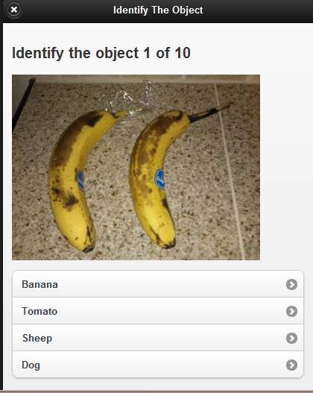

1. He finally checks his progress

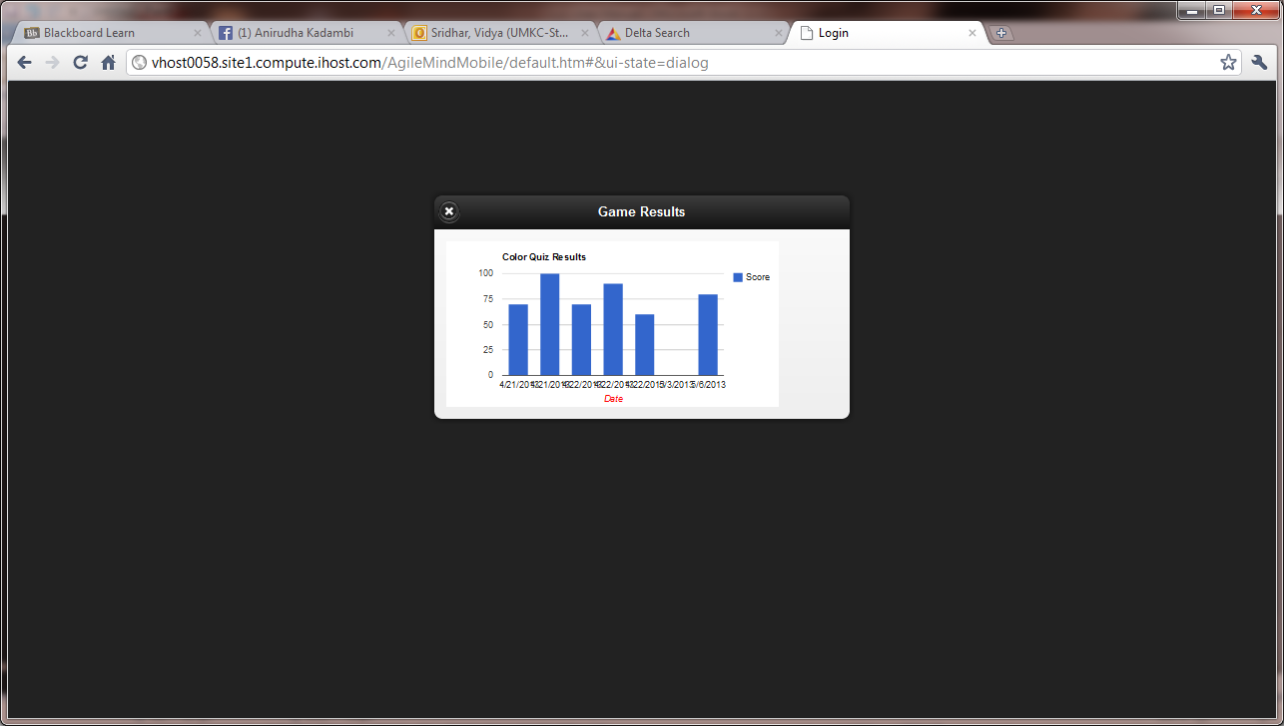

Bugs to be Resolved :   
  
- In the randomness of questions, sometimes the same questions are repeated multiple times. - - - Sometimes the short term quiz is repeated for the same person twice.